# Server- Side

**SOLUTION ARCHTIECHURE**

S E R V E R

# Client- Side

F I L E S

Static Resources

1. CSS
2. Script Image

HTTP GET Request HTTP Response

B R O W S E R

### HTML Templates

Request Data

### URL Encoding

* 1. GET/POST-Data



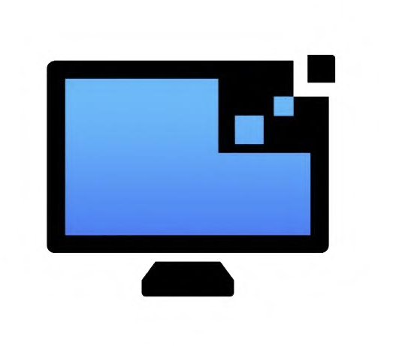

## Data HTM L

|  |  |
| --- | --- |
| **Team ID:** PNT2022TMID28350 | |
| **Project Name:** Customer Care Registry | |
| **Name** | **Register Number** |
| Vishnu Priyan V | 312419106157 |
| Vigneshwaran A | 312419106153 |
| Udhayanithi R | 312419106147 |
| Vejju Surya Teja | 312419106150 |

D A T A B A S E W E B A P P L I C A T I O N